**Maestría en Econometría - UTDT**

**Examen Final - Series de Tiempo**

**Ejercicio 1 (file named a merval.wf1).**

**(a)** *Find the preferred GARCH(p,q) model for the returns of the MERVAL. NB: The series is stock prices; you should model the returns.*

En la tabla 1, se presenta la estimación ARMA(2, 3) de los retornos del MERVAL. Se puede observar que todos los coeficientes son estadísticamente significativos.

Por otra parte, al mirar el correlograma de los residuos de esta estimación (tabla 2), se observa que las correlaciones no son significativamente distintas de cero, por lo que no queda estructura ARMA sin modelar. Sin embargo, al mirar el correlograma de los residuos al cuadrado de esta estimación (tabla 3), se observa que las correlaciones son significativamente distintas de cero, por lo que se debería modelar, de alguna manera, una varianza variable en el tiempo. Esto mismo se observa al realizar el test ARCH de heterocedasticidad (tabla 4), al rechazar la hipótesis nula de ausencia de heterocedasticidad.

**Tabla 1.** *Estimación ARMA(2,3) de los retornos del MERVAL.*

|  |  |  |  |  |
| --- | --- | --- | --- | --- |
| Dependent Variable: RETURNS_MERVAL | | | |  |
| Method: ARMA Maximum Likelihood (OPG - BHHH) | | | |  |
| Date: 07/07/24 Time: 16:39 | | |  |  |
| Sample: 2 399 | |  |  |  |
| Included observations: 398 | | |  |  |
| Convergence achieved after 31 iterations | | | |  |
| Coefficient covariance computed using outer product of gradients | | | | |
|  |  |  |  |  |
|  |  |  |  |  |
| Variable | Coefficient | Std. Error | t-Statistic | Prob. |
|  |  |  |  |  |
|  |  |  |  |  |
| AR(1) | 0.456715 | 0.181224 | 2.520170 | 0.0121 |
| AR(2) | -0.552417 | 0.180549 | -3.059654 | 0.0024 |
| MA(1) | -0.457149 | 0.192187 | -2.378664 | 0.0179 |
| MA(2) | 0.613557 | 0.187136 | 3.278677 | 0.0011 |
| MA(3) | 0.104576 | 0.056026 | 1.866545 | 0.0627 |
| SIGMASQ | 0.000736 | 3.30E-05 | 22.26812 | 0.0000 |
|  |  |  |  |  |
|  |  |  |  |  |
| R-squared | 0.028983 | Mean dependent var | | -0.000549 |
| Adjusted R-squared | 0.016598 | S.D. dependent var | | 0.027563 |
| S.E. of regression | 0.027333 | Akaike info criterion | | -4.346122 |
| Sum squared resid | 0.292869 | Schwarz criterion | | -4.286025 |
| Log likelihood | 870.8783 | Hannan-Quinn criter. | | -4.322318 |
| Durbin-Watson stat | 1.996032 |  |  |  |
|  |  |  |  |  |
|  |  |  |  |  |
| Inverted AR Roots | .23+.71i | .23-.71i | |  |
| Inverted MA Roots | .30+.78i | .30-.78i | -.15 | |
|  |  |  |  |  |
|  |  |  |  |  |

**Tabla 2.** *Correlograma de los residuos de la estimación ARMA(2,3) de los retornos del MERVAL.*

|  |  |  |  |  |  |  |
| --- | --- | --- | --- | --- | --- | --- |
| Date: 07/07/24 Time: 16:40 | | | |  |  |  |
| Sample (adjusted): 2 399 | | |  |  |  |  |
| Q-statistic probabilities adjusted for 5 ARMA terms | | | | | |  |
|  |  |  |  |  |  |  |
|  |  |  |  |  |  |  |
| Autocorrelation | Partial Correlation |  | AC | PAC | Q-Stat | Prob |
|  |  |  |  |  |  |  |
|  |  |  |  |  |  |  |
| .|. | | .|. | | 1 | 0.002 | 0.002 | 0.0011 |  |
| .|. | | .|. | | 2 | 0.010 | 0.010 | 0.0430 |  |
| .|. | | .|. | | 3 | -0.013 | -0.013 | 0.1104 |  |
| .|. | | .|. | | 4 | 0.042 | 0.042 | 0.8239 |  |
| .|. | | .|. | | 5 | -0.018 | -0.017 | 0.9481 |  |
| .|. | | .|. | | 6 | 0.001 | 0.000 | 0.9485 | 0.330 |
| .|. | | .|. | | 7 | 0.000 | 0.002 | 0.9485 | 0.622 |
| .|. | | .|. | | 8 | -0.021 | -0.023 | 1.1289 | 0.770 |
| .|. | | .|. | | 9 | -0.060 | -0.058 | 2.5959 | 0.628 |
| .|. | | .|. | | 10 | -0.002 | -0.002 | 2.5974 | 0.762 |
| .|. | | .|. | | 11 | -0.054 | -0.054 | 3.7967 | 0.704 |
| .|. | | .|. | | 12 | 0.060 | 0.061 | 5.2578 | 0.629 |
| .|. | | .|. | | 13 | 0.020 | 0.025 | 5.4290 | 0.711 |
| .|. | | .|. | | 14 | -0.010 | -0.014 | 5.4703 | 0.792 |
| .|. | | .|. | | 15 | 0.062 | 0.069 | 7.0716 | 0.719 |
| .|. | | .|. | | 16 | 0.047 | 0.041 | 8.0111 | 0.712 |
| *|. | | *|. | | 17 | -0.093 | -0.100 | 11.642 | 0.475 |
| .|. | | .|. | | 18 | 0.016 | 0.017 | 11.748 | 0.548 |
| .|. | | .|. | | 19 | 0.068 | 0.063 | 13.674 | 0.474 |
| .|. | | .|. | | 20 | -0.011 | -0.022 | 13.723 | 0.547 |
| .|. | | .|. | | 21 | 0.021 | 0.040 | 13.915 | 0.605 |
| .|. | | .|. | | 22 | 0.013 | 0.011 | 13.990 | 0.668 |
| .|. | | .|. | | 23 | -0.016 | -0.017 | 14.095 | 0.723 |
| .|. | | .|. | | 24 | 0.039 | 0.056 | 14.747 | 0.739 |
| .|. | | .|. | | 25 | 0.065 | 0.061 | 16.530 | 0.683 |
| .|. | | .|. | | 26 | 0.033 | 0.026 | 17.001 | 0.711 |
| .|. | | .|. | | 27 | 0.028 | 0.035 | 17.335 | 0.745 |
| .|* | | .|. | | 28 | 0.076 | 0.064 | 19.839 | 0.652 |
| .|. | | .|. | | 29 | -0.018 | -0.013 | 19.983 | 0.698 |
| .|. | | .|. | | 30 | -0.009 | 0.002 | 20.019 | 0.746 |
| .|. | | .|. | | 31 | -0.022 | -0.039 | 20.221 | 0.781 |
| .|. | | .|. | | 32 | 0.021 | 0.028 | 20.413 | 0.813 |
| .|. | | .|. | | 33 | -0.030 | -0.011 | 20.806 | 0.833 |
| .|. | | .|. | | 34 | -0.016 | -0.034 | 20.915 | 0.862 |
| *|. | | *|. | | 35 | -0.138 | -0.130 | 29.285 | 0.503 |
| .|. | | .|. | | 36 | 0.032 | 0.053 | 29.726 | 0.531 |
|  |  |  |  |  |  |  |
|  |  |  |  |  |  |  |

**Tabla 3.** *Correlograma de los residuos al cuadrado de la estimación ARMA(2,3) de los retornos del MERVAL.*

|  |  |  |  |  |  |  |
| --- | --- | --- | --- | --- | --- | --- |
| Date: 07/07/24 Time: 16:40 | | | |  |  |  |
| Sample (adjusted): 2 399 | | |  |  |  |  |
| Included observations: 398 after adjustments | | | | |  |  |
| Autocorrelation | Partial Correlation |  | AC | PAC | Q-Stat | Prob |
|  |  |  |  |  |  |  |
|  |  |  |  |  |  |  |
| .|** | | .|** | | 1 | 0.249 | 0.249 | 24.791 | 0.000 |
| .|* | | .|* | | 2 | 0.179 | 0.125 | 37.626 | 0.000 |
| .|* | | .|. | | 3 | 0.085 | 0.016 | 40.515 | 0.000 |
| .|** | | .|* | | 4 | 0.236 | 0.208 | 63.065 | 0.000 |
| .|*** | | .|** | | 5 | 0.384 | 0.316 | 122.81 | 0.000 |
| .|** | | .|* | | 6 | 0.272 | 0.116 | 152.86 | 0.000 |
| .|* | | .|. | | 7 | 0.127 | -0.023 | 159.39 | 0.000 |
| .|* | | .|. | | 8 | 0.105 | 0.016 | 163.86 | 0.000 |
| .|* | | .|. | | 9 | 0.120 | -0.023 | 169.75 | 0.000 |
| .|* | | *|. | | 10 | 0.133 | -0.077 | 176.99 | 0.000 |
| .|** | | .|* | | 11 | 0.222 | 0.091 | 197.18 | 0.000 |
| .|. | | *|. | | 12 | 0.024 | -0.112 | 197.41 | 0.000 |
| .|. | | .|. | | 13 | 0.048 | -0.032 | 198.36 | 0.000 |
| .|* | | .|. | | 14 | 0.078 | 0.060 | 200.88 | 0.000 |
| .|* | | .|. | | 15 | 0.131 | 0.060 | 208.06 | 0.000 |
| .|* | | .|* | | 16 | 0.186 | 0.097 | 222.55 | 0.000 |
| .|* | | .|* | | 17 | 0.151 | 0.128 | 232.10 | 0.000 |
| .|. | | .|. | | 18 | 0.073 | 0.034 | 234.32 | 0.000 |
| .|* | | .|. | | 19 | 0.112 | 0.043 | 239.60 | 0.000 |
| .|* | | .|. | | 20 | 0.097 | -0.017 | 243.55 | 0.000 |
| .|* | | .|. | | 21 | 0.169 | 0.024 | 255.58 | 0.000 |
| .|** | | .|. | | 22 | 0.223 | 0.073 | 276.56 | 0.000 |
| .|* | | .|. | | 23 | 0.105 | -0.025 | 281.20 | 0.000 |
| .|* | | .|. | | 24 | 0.102 | -0.016 | 285.61 | 0.000 |
| .|* | | .|. | | 25 | 0.118 | 0.031 | 291.59 | 0.000 |
| .|* | | .|. | | 26 | 0.108 | -0.040 | 296.56 | 0.000 |
| .|* | | .|. | | 27 | 0.147 | -0.008 | 305.82 | 0.000 |
| .|* | | .|* | | 28 | 0.173 | 0.108 | 318.68 | 0.000 |
| .|. | | .|. | | 29 | 0.062 | -0.027 | 320.34 | 0.000 |
| .|. | | *|. | | 30 | 0.045 | -0.072 | 321.20 | 0.000 |
| .|. | | .|. | | 31 | 0.004 | -0.054 | 321.21 | 0.000 |
| .|. | | *|. | | 32 | 0.034 | -0.083 | 321.71 | 0.000 |
| .|. | | *|. | | 33 | 0.065 | -0.077 | 323.57 | 0.000 |
| .|. | | .|. | | 34 | -0.007 | -0.051 | 323.59 | 0.000 |
| .|. | | .|. | | 35 | 0.030 | 0.044 | 323.98 | 0.000 |
| .|. | | .|. | | 36 | -0.028 | -0.040 | 324.31 | 0.000 |
|  |  |  |  |  |  |  |
|  |  |  |  |  |  |  |

**Tabla 4.** *Test de heterocedasticidad de la estimación ARMA(2, 3) de los retornos del MERVAL.*

|  |  |  |  |  |
| --- | --- | --- | --- | --- |
| Heteroskedasticity Test: ARCH | | |  |  |
|  |  |  |  |  |
|  |  |  |  |  |
| F-statistic | 26.05503 | Prob. F(1,395) | | 0.0000 |
| Obs*R-squared | 24.56650 | Prob. Chi-Square(1) | | 0.0000 |
|  |  |  |  |  |
|  |  |  |  |  |
|  |  |  |  |  |
| Test Equation: | |  |  |  |
| Dependent Variable: RESID^2 | | |  |  |
| Method: Least Squares | | |  |  |
| Date: 07/07/24 Time: 16:40 | | |  |  |
| Sample (adjusted): 3 399 | | |  |  |
| Included observations: 397 after adjustments | | | |  |
|  |  |  |  |  |
|  |  |  |  |  |
| Variable | Coefficient | Std. Error | t-Statistic | Prob. |
|  |  |  |  |  |
|  |  |  |  |  |
| C | 0.000554 | 8.91E-05 | 6.220486 | 0.0000 |
| RESID^2(-1) | 0.248758 | 0.048734 | 5.104413 | 0.0000 |
|  |  |  |  |  |
|  |  |  |  |  |
| R-squared | 0.061880 | Mean dependent var | | 0.000738 |
| Adjusted R-squared | 0.059505 | S.D. dependent var | | 0.001675 |
| S.E. of regression | 0.001624 | Akaike info criterion | | -10.00262 |
| Sum squared resid | 0.001042 | Schwarz criterion | | -9.982555 |
| Log likelihood | 1987.521 | Hannan-Quinn criter. | | -9.994675 |
| F-statistic | 26.05503 | Durbin-Watson stat | | 2.062083 |
| Prob(F-statistic) | 0.000001 |  |  |  |
|  |  |  |  |  |
|  |  |  |  |  |

Por lo tanto, en la tabla 5, se presenta la estimación GARCH(2, 1) de los retornos del MERVAL, que permite capturar la volatilidad condicional observada en estos datos financieros, donde la varianza cambia con el tiempo. Se puede observar que no todos los coeficientes son estadísticamente significativos. Sin embargo, esta especificación para la ecuación de la media y para la ecuación de la varianza posibilita que, en los correlogramas (de los residuos y de los residuos al cuadrado), las correlaciones no sean significativamente distintas de cero (tablas 6 y 7), por lo que no queda estructura ARMA ni estructura ARCH sin modelar.

**Tabla 5.** *Estimación GARCH(2, 1) de los retornos del MERVAL.*

|  |  |  |  |  |
| --- | --- | --- | --- | --- |
| Dependent Variable: RETURNS_MERVAL | | | |  |
| Method: ML ARCH - Normal distribution (BFGS / Marquardt steps) | | | | |
| Date: 07/07/24 Time: 16:53 | | |  |  |
| Sample (adjusted): 4 399 | | |  |  |
| Included observations: 396 after adjustments | | | |  |
| Convergence achieved after 74 iterations | | | |  |
| Coefficient covariance computed using outer product of gradients | | | | |
| MA Backcast: 1 3 | | |  |  |
| Presample variance: backcast (parameter = 0.7) | | | | |
| GARCH = C(6) + C(7)*RESID(-1)^2 + C(8)*RESID(-2)^2 + C(9)*GARCH(-1) | | | | |
|  |  |  |  |  |
|  |  |  |  |  |
| Variable | Coefficient | Std. Error | z-Statistic | Prob. |
|  |  |  |  |  |
|  |  |  |  |  |
| AR(1) | -1.163285 | 0.473399 | -2.457303 | 0.0140 |
| AR(2) | -0.218738 | 0.455269 | -0.480459 | 0.6309 |
| MA(1) | 1.167844 | 0.474992 | 2.458659 | 0.0139 |
| MA(2) | 0.290735 | 0.460294 | 0.631629 | 0.5276 |
| MA(3) | 0.048798 | 0.051518 | 0.947200 | 0.3435 |
|  |  |  |  |  |
|  |  |  |  |  |
|  | Variance Equation | |  |  |
|  |  |  |  |  |
|  |  |  |  |  |
| C | 2.47E-05 | 1.07E-05 | 2.315138 | 0.0206 |
| RESID(-1)^2 | -0.029510 | 0.034645 | -0.851778 | 0.3943 |
| RESID(-2)^2 | 0.272450 | 0.066137 | 4.119486 | 0.0000 |
| GARCH(-1) | 0.737587 | 0.051939 | 14.20107 | 0.0000 |
|  |  |  |  |  |
|  |  |  |  |  |
| R-squared | 0.009148 | Mean dependent var | | -0.000527 |
| Adjusted R-squared | -0.000989 | S.D. dependent var | | 0.027630 |
| S.E. of regression | 0.027644 | Akaike info criterion | | -4.692114 |
| Sum squared resid | 0.298795 | Schwarz criterion | | -4.601627 |
| Log likelihood | 938.0385 | Hannan-Quinn criter. | | -4.656266 |
| Durbin-Watson stat | 1.969163 |  |  |  |
|  |  |  |  |  |
|  |  |  |  |  |
| Inverted AR Roots | -.24 | -.93 | |  |
| Inverted MA Roots | -.13+.19i | -.13-.19i | -.91 | |
|  |  |  |  |  |
|  |  |  |  |  |

**Tabla 6.** *Correlograma de los residuos de la estimación GARCH(2, 1) de los retornos del MERVAL.*

|  |  |  |  |  |  |  |
| --- | --- | --- | --- | --- | --- | --- |
| Date: 07/07/24 Time: 16:53 | | | |  |  |  |
| Sample (adjusted): 4 399 | | |  |  |  |  |
| Q-statistic probabilities adjusted for 5 ARMA terms | | | | | |  |
|  |  |  |  |  |  |  |
|  |  |  |  |  |  |  |
| Autocorrelation | Partial Correlation |  | AC | PAC | Q-Stat | Prob* |
|  |  |  |  |  |  |  |
|  |  |  |  |  |  |  |
| .|. | | .|. | | 1 | 0.010 | 0.010 | 0.0391 |  |
| .|. | | .|. | | 2 | 0.009 | 0.009 | 0.0720 |  |
| .|. | | .|. | | 3 | 0.037 | 0.037 | 0.6350 |  |
| .|. | | .|. | | 4 | -0.003 | -0.004 | 0.6384 |  |
| .|. | | .|. | | 5 | 0.018 | 0.018 | 0.7717 |  |
| .|. | | .|. | | 6 | -0.017 | -0.019 | 0.8873 | 0.346 |
| .|. | | .|. | | 7 | 0.028 | 0.028 | 1.1992 | 0.549 |
| .|. | | .|. | | 8 | -0.031 | -0.033 | 1.5931 | 0.661 |
| .|. | | .|. | | 9 | -0.007 | -0.005 | 1.6119 | 0.807 |
| .|. | | .|. | | 10 | -0.057 | -0.059 | 2.9287 | 0.711 |
| *|. | | *|. | | 11 | -0.086 | -0.082 | 5.9295 | 0.431 |
| .|. | | .|. | | 12 | 0.039 | 0.040 | 6.5397 | 0.478 |
| .|. | | .|. | | 13 | 0.038 | 0.046 | 7.1461 | 0.521 |
| .|. | | .|. | | 14 | -0.010 | -0.007 | 7.1858 | 0.618 |
| .|. | | .|. | | 15 | 0.042 | 0.042 | 7.8994 | 0.639 |
| .|. | | .|. | | 16 | -0.017 | -0.021 | 8.0213 | 0.711 |
| .|. | | .|. | | 17 | -0.029 | -0.030 | 8.3667 | 0.756 |
| .|. | | .|. | | 18 | -0.052 | -0.054 | 9.4942 | 0.735 |
| .|. | | .|. | | 19 | 0.049 | 0.047 | 10.518 | 0.723 |
| .|. | | .|. | | 20 | 0.028 | 0.025 | 10.856 | 0.763 |
| .|. | | .|. | | 21 | 0.057 | 0.057 | 12.206 | 0.730 |
| .|* | | .|* | | 22 | 0.088 | 0.080 | 15.434 | 0.564 |
| .|. | | .|. | | 23 | 0.044 | 0.058 | 16.266 | 0.574 |
| .|. | | .|. | | 24 | 0.042 | 0.038 | 17.000 | 0.590 |
| .|* | | .|* | | 25 | 0.088 | 0.086 | 20.318 | 0.438 |
| .|. | | .|. | | 26 | 0.002 | -0.007 | 20.319 | 0.501 |
| .|. | | .|. | | 27 | 0.027 | 0.015 | 20.639 | 0.543 |
| .|. | | .|. | | 28 | 0.006 | -0.014 | 20.654 | 0.602 |
| .|. | | .|. | | 29 | -0.004 | -0.003 | 20.661 | 0.659 |
| .|. | | .|. | | 30 | -0.017 | -0.003 | 20.791 | 0.704 |
| .|. | | .|. | | 31 | -0.031 | -0.012 | 21.199 | 0.732 |
| .|. | | .|. | | 32 | -0.018 | -0.006 | 21.332 | 0.771 |
| .|. | | .|. | | 33 | 0.032 | 0.059 | 21.771 | 0.792 |
| .|. | | .|. | | 34 | -0.007 | -0.012 | 21.795 | 0.829 |
| .|. | | .|. | | 35 | -0.057 | -0.055 | 23.217 | 0.806 |
| .|. | | .|. | | 36 | 0.026 | 0.026 | 23.504 | 0.830 |
|  |  |  |  |  |  |  |
|  |  |  |  |  |  |  |

**Tabla 7.** *Correlograma de los residuos al cuadrado de la estimación GARCH(2, 1) de los retornos del MERVAL.*

|  |  |  |  |  |  |  |
| --- | --- | --- | --- | --- | --- | --- |
| Date: 07/07/24 Time: 16:53 | | | |  |  |  |
| Sample (adjusted): 4 399 | | |  |  |  |  |
| Included observations: 396 after adjustments | | | | |  |  |
| Autocorrelation | Partial Correlation |  | AC | PAC | Q-Stat | Prob* |
|  |  |  |  |  |  |  |
|  |  |  |  |  |  |  |
| .|. | | .|. | | 1 | 0.007 | 0.007 | 0.0173 | 0.895 |
| .|. | | .|. | | 2 | -0.005 | -0.005 | 0.0291 | 0.986 |
| .|. | | .|. | | 3 | -0.014 | -0.013 | 0.1025 | 0.992 |
| .|. | | .|. | | 4 | 0.013 | 0.013 | 0.1726 | 0.996 |
| .|. | | .|. | | 5 | -0.025 | -0.026 | 0.4331 | 0.994 |
| .|. | | .|. | | 6 | 0.001 | 0.002 | 0.4340 | 0.999 |
| .|. | | .|. | | 7 | -0.012 | -0.012 | 0.4956 | 0.999 |
| .|. | | .|. | | 8 | -0.042 | -0.043 | 1.2136 | 0.997 |
| .|. | | .|. | | 9 | -0.010 | -0.009 | 1.2575 | 0.999 |
| .|. | | .|. | | 10 | -0.000 | -0.002 | 1.2576 | 1.000 |
| .|* | | .|* | | 11 | 0.135 | 0.135 | 8.7591 | 0.644 |
| *|. | | *|. | | 12 | -0.098 | -0.102 | 12.703 | 0.391 |
| .|. | | .|. | | 13 | -0.062 | -0.062 | 14.287 | 0.354 |
| .|. | | .|. | | 14 | -0.041 | -0.039 | 14.991 | 0.379 |
| .|. | | .|. | | 15 | 0.024 | 0.019 | 15.236 | 0.435 |
| .|. | | .|. | | 16 | 0.018 | 0.026 | 15.378 | 0.497 |
| .|. | | .|. | | 17 | 0.039 | 0.034 | 16.017 | 0.523 |
| .|. | | .|. | | 18 | -0.025 | -0.025 | 16.285 | 0.573 |
| .|. | | .|. | | 19 | 0.042 | 0.050 | 17.007 | 0.589 |
| .|. | | .|. | | 20 | 0.001 | -0.007 | 17.007 | 0.653 |
| .|. | | .|. | | 21 | -0.030 | -0.039 | 17.377 | 0.688 |
| .|. | | .|. | | 22 | 0.041 | 0.023 | 18.087 | 0.701 |
| .|. | | .|. | | 23 | -0.045 | -0.021 | 18.944 | 0.704 |
| .|. | | .|. | | 24 | -0.007 | 0.007 | 18.964 | 0.754 |
| .|* | | .|* | | 25 | 0.101 | 0.108 | 23.265 | 0.562 |
| .|* | | .|. | | 26 | 0.077 | 0.057 | 25.810 | 0.474 |
| .|. | | .|. | | 27 | 0.010 | 0.009 | 25.855 | 0.527 |
| .|. | | .|. | | 28 | 0.034 | 0.030 | 26.364 | 0.553 |
| .|* | | .|* | | 29 | 0.075 | 0.093 | 28.764 | 0.477 |
| .|. | | .|. | | 30 | -0.014 | -0.022 | 28.850 | 0.525 |
| .|. | | .|. | | 31 | -0.010 | 0.001 | 28.896 | 0.575 |
| .|. | | .|. | | 32 | 0.004 | 0.018 | 28.903 | 0.624 |
| .|. | | .|. | | 33 | -0.004 | -0.006 | 28.909 | 0.671 |
| .|. | | .|. | | 34 | -0.053 | -0.033 | 30.151 | 0.657 |
| .|. | | .|. | | 35 | 0.006 | 0.006 | 30.170 | 0.700 |
| .|. | | *|. | | 36 | -0.051 | -0.084 | 31.311 | 0.691 |
|  |  |  |  |  |  |  |
|  |  |  |  |  |  |  |

**(b)** *Choose three stocks and repeat point (a). Critically comment the difference between the results in (a) and (b).*

En las tablas 8, 9 y 10, se presentan las estimaciones GARCH de los retornos de ALUA, BMA y COME, respectivamente. Al igual que en el inciso (a), se selecciona aquella especificación para la ecuación de la media y para la ecuación de la varianza que posibilita que, en los correlogramas (de los residuos y de los residuos al cuadrado), las correlaciones no sean significativamente distintas de cero, de manera que no quede estructura ARMA ni estructura ARCH sin modelar.

Se puede observar que, a diferencia de los resultados del inciso (a), los modelos GARCH estimados para los retornos de las tres acciones individuales muestran diferencias significativas en la volatilidad en comparación con el modelo estimado para el retorno del MERVAL. En particular, se tiene que:

* En ALUA y COME, la volatilidad tiene una mayor respuesta a *shocks* recientes (coeficiente RESID(-1)^2 significativo y más alto) y una mayor persistencia (coeficiente GARCH(-1) más alto).
* En BMA, la volatilidad tiene una mayor respuesta a *shocks* recientes (coeficiente RESID(-1)^2 significativo y más alto) y una menor persistencia (coeficiente GARCH(-1) más bajo).

Se destaca que, mientras que, para el MERVAL, el coeficiente RESID(-1)^2 no es estadísticamente significativo, para ALUA, BMA y COME, sí lo es, indicando una respuesta inmediata a los *shocks* recientes en la volatilidad de estas acciones individuales.

El índice MERVAL presenta un comportamiento más suavizado en la volatilidad, ya que agrupa y promedia la volatilidad de varias acciones. Las acciones individuales, por otro lado, muestran variaciones más significativas en la volatilidad y en la respuesta a *shocks* recientes debido a características específicas de cada empresa y a su exposición a riesgos idiosincráticos. Por lo tanto, los resultados sugieren que la volatilidad y la persistencia de los retornos varían considerablemente entre diferentes activos individuales en comparación con un índice agregado como el MERVAL, lo cual destaca la importancia de modelar cada activo por separado para capturar, adecuadamente, su dinámica de volatilidad específica.

**Tabla 8.** *Estimación GARCH(1, 1) de los retornos de ALUA.*

|  |  |  |  |  |
| --- | --- | --- | --- | --- |
| Dependent Variable: RETURNS_ALUA | | | |  |
| Method: ML ARCH - Normal distribution (BFGS / Marquardt steps) | | | | |
| Date: 07/07/24 Time: 16:53 | | |  |  |
| Sample (adjusted): 4 399 | | |  |  |
| Included observations: 396 after adjustments | | | |  |
| Convergence achieved after 37 iterations | | | |  |
| Coefficient covariance computed using outer product of gradients | | | | |
| MA Backcast: 3 | |  |  |  |
| Presample variance: backcast (parameter = 0.7) | | | | |
| GARCH = C(5) + C(6)*RESID(-1)^2 + C(7)*GARCH(-1) | | | | |
|  |  |  |  |  |
|  |  |  |  |  |
| Variable | Coefficient | Std. Error | z-Statistic | Prob. |
|  |  |  |  |  |
|  |  |  |  |  |
| C | -0.000741 | 0.001322 | -0.560684 | 0.5750 |
| AR(1) | -0.188567 | 0.442911 | -0.425746 | 0.6703 |
| AR(2) | 0.117691 | 0.049232 | 2.390540 | 0.0168 |
| MA(1) | 0.192637 | 0.448716 | 0.429307 | 0.6677 |
|  |  |  |  |  |
|  |  |  |  |  |
|  | Variance Equation | |  |  |
|  |  |  |  |  |
|  |  |  |  |  |
| C | 3.90E-06 | 2.57E-06 | 1.514774 | 0.1298 |
| RESID(-1)^2 | 0.068281 | 0.012561 | 5.436135 | 0.0000 |
| GARCH(-1) | 0.931679 | 0.010037 | 92.82335 | 0.0000 |
|  |  |  |  |  |
|  |  |  |  |  |
| R-squared | 0.015071 | Mean dependent var | | -0.001763 |
| Adjusted R-squared | 0.007534 | S.D. dependent var | | 0.030238 |
| S.E. of regression | 0.030124 | Akaike info criterion | | -4.402836 |
| Sum squared resid | 0.355718 | Schwarz criterion | | -4.332457 |
| Log likelihood | 878.7615 | Hannan-Quinn criter. | | -4.374954 |
| Durbin-Watson stat | 1.921322 |  |  |  |
|  |  |  |  |  |
|  |  |  |  |  |
| Inverted AR Roots | .26 | -.45 | |  |
| Inverted MA Roots | -.19 | |  |  |
|  |  |  |  |  |
|  |  |  |  |  |

**Tabla 9.** *Estimación GARCH(1, 1) de los retornos de BMA.*

|  |  |  |  |  |
| --- | --- | --- | --- | --- |
| Dependent Variable: RETURNS_BMA | | | |  |
| Method: ML ARCH - Normal distribution (BFGS / Marquardt steps) | | | | |
| Date: 07/07/24 Time: 16:54 | | |  |  |
| Sample (adjusted): 3 399 | | |  |  |
| Included observations: 397 after adjustments | | | |  |
| Convergence achieved after 17 iterations | | | |  |
| Coefficient covariance computed using outer product of gradients | | | | |
| Presample variance: backcast (parameter = 0.7) | | | | |
| GARCH = C(2) + C(3)*RESID(-1)^2 + C(4)*GARCH(-1) | | | | |
|  |  |  |  |  |
|  |  |  |  |  |
| Variable | Coefficient | Std. Error | z-Statistic | Prob. |
|  |  |  |  |  |
|  |  |  |  |  |
| AR(1) | 0.018914 | 0.053135 | 0.355971 | 0.7219 |
|  |  |  |  |  |
|  |  |  |  |  |
|  | Variance Equation | |  |  |
|  |  |  |  |  |
|  |  |  |  |  |
| C | 0.000131 | 2.99E-05 | 4.366203 | 0.0000 |
| RESID(-1)^2 | 0.266688 | 0.058085 | 4.591366 | 0.0000 |
| GARCH(-1) | 0.607911 | 0.067766 | 8.970790 | 0.0000 |
|  |  |  |  |  |
|  |  |  |  |  |
| R-squared | 0.005470 | Mean dependent var | | -0.000307 |
| Adjusted R-squared | 0.005470 | S.D. dependent var | | 0.032882 |
| S.E. of regression | 0.032792 | Akaike info criterion | | -4.269497 |
| Sum squared resid | 0.425817 | Schwarz criterion | | -4.229356 |
| Log likelihood | 851.4951 | Hannan-Quinn criter. | | -4.253596 |
| Durbin-Watson stat | 1.727468 |  |  |  |
|  |  |  |  |  |
|  |  |  |  |  |
| Inverted AR Roots | .02 | |  |  |
|  |  |  |  |  |
|  |  |  |  |  |

**Tabla 10.** *Estimación GARCH(1, 1) de los retornos de COME.*

|  |  |  |  |  |
| --- | --- | --- | --- | --- |
| Dependent Variable: RETURNS_COME | | | |  |
| Method: ML ARCH - Normal distribution (BFGS / Marquardt steps) | | | | |
| Date: 07/07/24 Time: 16:54 | | |  |  |
| Sample (adjusted): 2 399 | | |  |  |
| Included observations: 398 after adjustments | | | |  |
| Convergence achieved after 22 iterations | | | |  |
| Coefficient covariance computed using outer product of gradients | | | | |
| Presample variance: backcast (parameter = 0.7) | | | | |
| GARCH = C(2) + C(3)*RESID(-1)^2 + C(4)*GARCH(-1) | | | | |
|  |  |  |  |  |
|  |  |  |  |  |
| Variable | Coefficient | Std. Error | z-Statistic | Prob. |
|  |  |  |  |  |
|  |  |  |  |  |
| C | -0.001392 | 0.001745 | -0.798055 | 0.4248 |
|  |  |  |  |  |
|  |  |  |  |  |
|  | Variance Equation | |  |  |
|  |  |  |  |  |
|  |  |  |  |  |
| C | 9.24E-05 | 3.00E-05 | 3.081633 | 0.0021 |
| RESID(-1)^2 | 0.155680 | 0.033919 | 4.589791 | 0.0000 |
| GARCH(-1) | 0.782007 | 0.044545 | 17.55558 | 0.0000 |
|  |  |  |  |  |
|  |  |  |  |  |
| R-squared | -0.000681 | Mean dependent var | | -0.000450 |
| Adjusted R-squared | -0.000681 | S.D. dependent var | | 0.036159 |
| S.E. of regression | 0.036172 | Akaike info criterion | | -3.912026 |
| Sum squared resid | 0.519428 | Schwarz criterion | | -3.871961 |
| Log likelihood | 782.4932 | Hannan-Quinn criter. | | -3.896157 |
| Durbin-Watson stat | 1.840036 |  |  |  |
|  |  |  |  |  |
|  |  |  |  |  |

**(c)** *Estimate a Multivariate GARCH model using two of the stocks chosen in (b). Compare the results and comment.*

En la tabla 11, se presenta la estimación Multivariate GARCH (*Diagonal* BEKK) de los retornos de ALUA y BMA. Se puede observar que:

* En el modelo univariado de ALUA, el impacto de los *shocks* recientes (RESID(-1)^2) es 0,068266, mientras que, en el modelo MGARCH, el coeficiente A1(1,1) es 0,245385, indicando un mayor impacto en el contexto multivariado.
* En el modelo univariado de BMA, el impacto de los *shocks* recientes (RESID(-1)^2) es 0,266680, mientras que, en el modelo MGARCH, el coeficiente A2(2,2) es 0,469748, indicando un mayor impacto en el contexto multivariado.
* En el modelo univariado de ALUA, la persistencia (GARCH(-1)) es alta (0,931693), lo cual es consistente con el coeficiente B1(1,1) en el modelo MGARCH (0,966751).
* En el modelo univariado de BMA, la persistencia (GARCH(-1)) es 0,607835, mientras que, en el modelo MGARCH, el coeficiente B1(2,2) es 0,806615, indicando un mayor impacto en el contexto multivariado.
* El coeficiente M(1,2) en el modelo MGARCH es significativo, lo que sugiere una correlación significativa entre las volatilidades de ALUA y BMA, la cual no puede ser captada por los modelos univariados e indica que los *shocks* de volatilidad en una acción pueden afectar la volatilidad de la otra.

Por lo tanto, la estimación MGARCH (*Diagonal* BEKK) proporciona una visión más completa de las dinámicas de volatilidad entre ALUA y BMA. Los resultados indican una alta persistencia de la volatilidad y un efecto significativo de los *shocks* pasados en ambas series. Además, se observa una correlación significativa entre las volatilidades de las dos acciones, lo que resalta la importancia de modelar conjuntamente las series de tiempo para una mejor comprensión de los riesgos financieros.

**Tabla 11.** *Estimación Multivariate GARCH (Diagonal BEKK) de los retornos de ALUA y BMA.*

|  |  |  |  |  |
| --- | --- | --- | --- | --- |
| System: SYS_MGARCH_ALUA_BMA | | |  |  |
| Estimation Method: ARCH Maximum Likelihood (BFGS / Marquardt steps) | | | | |
| Covariance specification: Diagonal BEKK | | | |  |
| Date: 07/07/24 Time: 17:05 | | |  |  |
| Sample: 2 399 | |  |  |  |
| Included observations: 398 | | |  |  |
| Total system (balanced) observations 796 | | | |  |
| Presample covariance: backcast (parameter =0.7) | | | |  |
| Convergence achieved after 22 iterations | | | |  |
| Coefficient covariance computed using outer product of gradients | | | | |
|  |  |  |  |  |
|  |  |  |  |  |
|  | Coefficient | Std. Error | z-Statistic | Prob. |
|  |  |  |  |  |
|  |  |  |  |  |
| C(1) | -0.000724 | 0.001073 | -0.674356 | 0.5001 |
| C(2) | 0.000565 | 0.001319 | 0.428326 | 0.6684 |
|  |  |  |  |  |
|  |  |  |  |  |
|  | Variance Equation Coefficients | | |  |
|  |  |  |  |  |
|  |  |  |  |  |
| C(3) | 7.82E-06 | 2.44E-06 | 3.200061 | 0.0014 |
| C(4) | 2.15E-05 | 8.88E-06 | 2.420700 | 0.0155 |
| C(5) | 0.000125 | 3.08E-05 | 4.068098 | 0.0000 |
| C(6) | 0.245385 | 0.020778 | 11.81008 | 0.0000 |
| C(7) | 0.469748 | 0.055345 | 8.487638 | 0.0000 |
| C(8) | 0.966751 | 0.004133 | 233.8900 | 0.0000 |
| C(9) | 0.806615 | 0.039819 | 20.25688 | 0.0000 |
|  |  |  |  |  |
|  |  |  |  |  |
| Log likelihood | 1752.934 | Schwarz criterion | | -8.673340 |
| Avg. log likelihood | 2.202178 | Hannan-Quinn criter. | | -8.727780 |
| Akaike info criterion | -8.763486 |  |  |  |
|  |  |  |  |  |
|  |  |  |  |  |
|  |  |  |  |  |
| Equation: RETURNS_ALUA = C(1) | | |  |  |
| R-squared | -0.001210 | Mean dependent var | | -0.001772 |
| Adjusted R-squared | -0.001210 | S.D. dependent var | | 0.030162 |
| S.E. of regression | 0.030180 | Sum squared resid | | 0.361609 |
| Durbin-Watson stat | 1.905700 |  |  |  |
|  |  |  |  |  |
| Equation: RETURNS_BMA = C(2) | | |  |  |
| R-squared | -0.000806 | Mean dependent var | | -0.000367 |
| Adjusted R-squared | -0.000806 | S.D. dependent var | | 0.032862 |
| S.E. of regression | 0.032875 | Sum squared resid | | 0.429066 |
| Durbin-Watson stat | 1.681994 |  |  |  |
|  |  |  |  |  |
|  |  |  |  |  |
|  |  |  |  |  |
| Covariance specification: Diagonal BEKK | | | |  |
| GARCH = M + A1*RESID(-1)*RESID(-1)'*A1 + B1*GARCH(-1)*B1 | | | | |
| M is an indefinite matrix | | |  |  |
| A1 is a diagonal matrix | | |  |  |
| B1 is a diagonal matrix | | |  |  |
|  |  |  |  |  |
|  |  |  |  |  |
|  | Transformed Variance Coefficients | | | |
|  |  |  |  |  |
|  |  |  |  |  |
|  | Coefficient | Std. Error | z-Statistic | Prob. |
|  |  |  |  |  |
|  |  |  |  |  |
| M(1,1) | 7.82E-06 | 2.44E-06 | 3.200061 | 0.0014 |
| M(1,2) | 2.15E-05 | 8.88E-06 | 2.420700 | 0.0155 |
| M(2,2) | 0.000125 | 3.08E-05 | 4.068098 | 0.0000 |
| A1(1,1) | 0.245385 | 0.020778 | 11.81008 | 0.0000 |
| A1(2,2) | 0.469748 | 0.055345 | 8.487638 | 0.0000 |
| B1(1,1) | 0.966751 | 0.004133 | 233.8900 | 0.0000 |
| B1(2,2) | 0.806615 | 0.039819 | 20.25688 | 0.0000 |
|  |  |  |  |  |
|  |  |  |  |  |

**Ejercicio 2 (file named a money.wf1).**

*The data file contains the following variables for real GDP: pbi_real (using the Indec) and pbi_privado (using a private sector index). Both measures of GDP need to be seasonally adjusted. For both measures of real GDP, identify the booms and recessions of the Argentinean economy, using:*

**(a)** *A Markov Switching Model.*

En las figuras 1 y 2, se presentan las series originales y ajustadas estacionalmente del pbi_real y del pbi_privado, respectivamente.

**Figura 1.** *Series pbi_real (1980Q1 - 2010Q4).*



**Figura 2.** *Series pbi_privado (1980Q1 - 2010Q4).*



En las tablas 12 y 13, se presentan las estimaciones de un modelo *Markov Switching* usando el pbi_real_sa y el pbi_privado_sa, respectivamente. En las figuras 3 y 4, se presentan las probabilidades predichas de los regímenes para cada uno de estos modelos. Se puede observar que, en la estimación para el pbi_real_sa, el régimen 1 (régimen 2) representa auge (recesión), mientras que, en la estimación para el pbi_privado_sa, el régimen 2 (régimen 1) representa auge (recesión); aunque, en este último caso, no parece tan clara la diferencia.

**Tabla 12.** *Modelo Markov Switching - pbi_real_sa.*

|  |  |  |  |  |
| --- | --- | --- | --- | --- |
| Dependent Variable: PBI_REAL_SA | | | |  |
| Method: Markov Switching Regression (BFGS / Marquardt steps) | | | | |
| Date: 07/07/24 Time: 17:08 | | |  |  |
| Sample: 1980Q1 2010Q4 | | |  |  |
| Included observations: 124 | | |  |  |
| Number of states: 2 | | |  |  |
| Initial probabilities obtained from ergodic solution | | | | |
| Standard errors & covariance computed using observed Hessian | | | | |
| Random search: 25 starting values with 10 iterations using 1 standard | | | | |
| deviation (rng=kn, seed=12345) | | | |  |
| Convergence achieved after 9 iterations | | | |  |
|  |  |  |  |  |
|  |  |  |  |  |
| Variable | Coefficient | Std. Error | z-Statistic | Prob. |
|  |  |  |  |  |
|  |  |  |  |  |
| Regime 1 | | | | |
|  |  |  |  |  |
|  |  |  |  |  |
| C | 192819.4 | 2307.619 | 83.55774 | 0.0000 |
| IPC | 1839.910 | 30.93728 | 59.47227 | 0.0000 |
| TASA_DE_INTERES | 30.39731 | 14.79347 | 2.054779 | 0.0399 |
| LOG(SIGMA) | 8.900816 | 0.101430 | 87.75315 | 0.0000 |
|  |  |  |  |  |
|  |  |  |  |  |
| Regime 2 | | | | |
|  |  |  |  |  |
|  |  |  |  |  |
| C | 158770.1 | 7885.347 | 20.13483 | 0.0000 |
| IPC | 1738.180 | 149.5437 | 11.62323 | 0.0000 |
| TASA_DE_INTERES | 20.64345 | 14.30289 | 1.443306 | 0.1489 |
| LOG(SIGMA) | 9.624762 | 0.110296 | 87.26267 | 0.0000 |
|  |  |  |  |  |
|  |  |  |  |  |
| Transition Matrix Parameters | | | | |
|  |  |  |  |  |
|  |  |  |  |  |
| P11-C | 3.719432 | 0.775294 | 4.797448 | 0.0000 |
| P21-C | -3.064822 | 0.671469 | -4.564353 | 0.0000 |
|  |  |  |  |  |
|  |  |  |  |  |
| Mean dependent var | 255002.8 | S.D. dependent var | | 64595.00 |
| S.E. of regression | 13188.13 | Sum squared resid | | 2.02E+10 |
| Durbin-Watson stat | 0.455049 | Log likelihood | | -1332.527 |
| Akaike info criterion | 21.65367 | Schwarz criterion | | 21.88111 |
| Hannan-Quinn criter. | 21.74606 |  |  |  |
|  |  |  |  |  |
|  |  |  |  |  |

**Tabla 13.** *Modelo Markov Switching - pbi_privado_sa.*

|  |  |  |  |  |
| --- | --- | --- | --- | --- |
| Dependent Variable: PBI_PRIVADO_SA | | | |  |
| Method: Markov Switching Regression (BFGS / Marquardt steps) | | | | |
| Date: 07/07/24 Time: 17:10 | | |  |  |
| Sample (adjusted): 1980Q2 2010Q4 | | | |  |
| Included observations: 123 after adjustments | | | |  |
| Number of states: 2 | | |  |  |
| Initial probabilities obtained from ergodic solution | | | | |
| Standard errors & covariance computed using observed Hessian | | | | |
| Random search: 25 starting values with 10 iterations using 1 standard | | | | |
| deviation (rng=kn, seed=12345) | | | |  |
| Convergence achieved after 13 iterations | | | |  |
|  |  |  |  |  |
|  |  |  |  |  |
| Variable | Coefficient | Std. Error | z-Statistic | Prob. |
|  |  |  |  |  |
|  |  |  |  |  |
| Regime 1 | | | | |
|  |  |  |  |  |
|  |  |  |  |  |
| C | 202191.5 | 2005.275 | 100.8298 | 0.0000 |
| IPC_PRIVADO | 1467.036 | 39.64428 | 37.00497 | 0.0000 |
| TASA_DE_INTERES | -23.47269 | 7.158705 | -3.278902 | 0.0010 |
| LOG(SIGMA) | 9.106752 | 0.093511 | 97.38715 | 0.0000 |
|  |  |  |  |  |
|  |  |  |  |  |
| Regime 2 | | | | |
|  |  |  |  |  |
|  |  |  |  |  |
| C | 228547.9 | 5997.142 | 38.10947 | 0.0000 |
| IPC_PRIVADO | 358.6716 | 59.13025 | 6.065789 | 0.0000 |
| TASA_DE_INTERES | -283.3566 | 67.11712 | -4.221823 | 0.0000 |
| LOG(SIGMA) | 9.815532 | 0.108879 | 90.15058 | 0.0000 |
|  |  |  |  |  |
|  |  |  |  |  |
| Transition Matrix Parameters | | | | |
|  |  |  |  |  |
|  |  |  |  |  |
| P11-C | 3.234949 | 0.644011 | 5.023123 | 0.0000 |
| P21-C | -2.929313 | 0.660154 | -4.437317 | 0.0000 |
|  |  |  |  |  |
|  |  |  |  |  |
| Mean dependent var | 243808.3 | S.D. dependent var | | 45131.72 |
| S.E. of regression | 15416.44 | Sum squared resid | | 2.73E+10 |
| Durbin-Watson stat | 0.725943 | Log likelihood | | -1348.225 |
| Akaike info criterion | 22.08496 | Schwarz criterion | | 22.31359 |
| Hannan-Quinn criter. | 22.17783 |  |  |  |
|  |  |  |  |  |
|  |  |  |  |  |

**Figura 3.** *Probabilidades predichas de los regímenes del modelo para pbi_real_sa.*

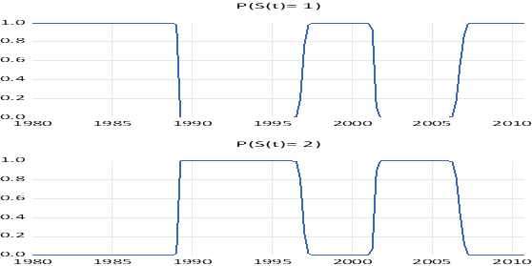

**Figura 4.** *Probabilidades predichas de los regímenes del modelo para pbi_privado_sa.*

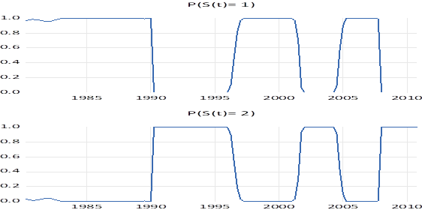

**(b)** *A STAR Model. Discuss which variable (of those included in the data set) should be used as a threshold, and why?*

En las tablas 14 y 15, se presentan las estimaciones de un modelo STAR usando el pbi_real_sa y el pbi_privado_sa, respectivamente. En las figuras 5 y 6, se presentan los *Threshold Smoothing Weights* para cada uno de estos modelos.

La tasa de interés (rezagada un período) puede ser una buena elección como variable umbral. La tasa de interés es una herramienta clave de la política monetaria, que refleja las decisiones del Banco Central e impacta en la economía real, es decir, en el consumo, la inversión y el ahorro, afectando, directamente, al PBI. A su vez, la tasa de interés puede reaccionar, rápidamente, a cambios en las expectativas económicas, capturando, de manera efectiva, los puntos de inflexión entre auges y recesiones.

**Tabla 14.** *Modelo STAR - pbi_real_sa.*

|  |  |  |  |  |
| --- | --- | --- | --- | --- |
| Dependent Variable: PBI_REAL_SA_NORM | | | |  |
| Method: Smooth Threshold Regression | | | |  |
| Transition function: Logistic | | |  |  |
| Date: 07/07/24 Time: 17:22 | | |  |  |
| Sample (adjusted): 1980Q4 2010Q4 | | | |  |
| Included observations: 121 after adjustments | | | |  |
| Threshold variable: TASA_DE_INTERES_NORM(-1) | | | |  |
| Starting values: Grid search with concentrated regression coefficients | | | | |
| Ordinary standard errors & covariance using outer product of gradients | | | | |
| Convergence achieved after 9 iterations | | | |  |
|  |  |  |  |  |
|  |  |  |  |  |
| Variable | Coefficient | Std. Error | t-Statistic | Prob. |
|  |  |  |  |  |
|  |  |  |  |  |
| Threshold Variables (linear part) | | | | |
|  |  |  |  |  |
|  |  |  |  |  |
| C | 0.216578 | 0.618577 | 0.350123 | 0.7269 |
| PBI_REAL_SA_NORM(-1) | 1.722439 | 1.185703 | 1.452673 | 0.1491 |
| PBI_REAL_SA_NORM(-2) | -0.497010 | 0.649614 | -0.765085 | 0.4458 |
| PBI_REAL_SA_NORM(-3) | -0.041362 | 0.262400 | -0.157630 | 0.8750 |
|  |  |  |  |  |
|  |  |  |  |  |
| Threshold Variables (nonlinear part) | | | | |
|  |  |  |  |  |
|  |  |  |  |  |
| C | -0.566514 | 0.733759 | -0.772071 | 0.4417 |
| PBI_REAL_SA_NORM(-1) | -1.119675 | 1.396491 | -0.801778 | 0.4244 |
| PBI_REAL_SA_NORM(-2) | 0.540136 | 0.786290 | 0.686943 | 0.4936 |
| PBI_REAL_SA_NORM(-3) | 0.034840 | 0.415207 | 0.083910 | 0.9333 |
|  |  |  |  |  |
|  |  |  |  |  |
| Slopes | | | | |
|  |  |  |  |  |
|  |  |  |  |  |
| SLOPE | 2.510975 | 4.086124 | 0.614513 | 0.5401 |
|  |  |  |  |  |
|  |  |  |  |  |
| Thresholds | | | | |
|  |  |  |  |  |
|  |  |  |  |  |
| THRESHOLD | -0.178339 | 0.825599 | -0.216011 | 0.8294 |
|  |  |  |  |  |
|  |  |  |  |  |
| R-squared | 0.993567 | Mean dependent var | | 0.020862 |
| Adjusted R-squared | 0.993045 | S.D. dependent var | | 1.003416 |
| S.E. of regression | 0.083679 | Akaike info criterion | | -2.044624 |
| Sum squared resid | 0.777245 | Schwarz criterion | | -1.813567 |
| Log likelihood | 133.6998 | Hannan-Quinn criter. | | -1.950783 |
| F-statistic | 1904.858 | Durbin-Watson stat | | 1.881384 |
| Prob(F-statistic) | 0.000000 |  |  |  |
|  |  |  |  |  |
|  |  |  |  |  |

**Tabla 15.** *Modelo STAR - pbi_privado_sa.*

|  |  |  |  |  |
| --- | --- | --- | --- | --- |
| Dependent Variable: PBI_PRIVADO_SA_NORM | | | |  |
| Method: Smooth Threshold Regression | | | |  |
| Transition function: Logistic | | |  |  |
| Date: 07/07/24 Time: 17:23 | | |  |  |
| Sample (adjusted): 1981Q1 2010Q4 | | | |  |
| Included observations: 120 after adjustments | | | |  |
| Threshold variable: TASA_DE_INTERES_NORM(-1) | | | |  |
| Starting values: Grid search with concentrated regression coefficients | | | | |
| Ordinary standard errors & covariance using outer product of gradients | | | | |
| Convergence achieved after 33 iterations | | | |  |
|  |  |  |  |  |
|  |  |  |  |  |
| Variable | Coefficient | Std. Error | t-Statistic | Prob. |
|  |  |  |  |  |
|  |  |  |  |  |
| Threshold Variables (linear part) | | | | |
|  |  |  |  |  |
|  |  |  |  |  |
| C | 2639.333 | 384288.7 | 0.006868 | 0.9945 |
| PBI_PRIVADO_SA_NORM(-1) | 5366.553 | 781172.4 | 0.006870 | 0.9945 |
| PBI_PRIVADO_SA_NORM(-2) | -3439.490 | 500728.0 | -0.006869 | 0.9945 |
| PBI_PRIVADO_SA_NORM(-3) | -335.5373 | 48875.62 | -0.006865 | 0.9945 |
|  |  |  |  |  |
|  |  |  |  |  |
| Threshold Variables (nonlinear part) | | | | |
|  |  |  |  |  |
|  |  |  |  |  |
| C | -2639.773 | 384288.7 | -0.006869 | 0.9945 |
| PBI_PRIVADO_SA_NORM(-1) | -5366.079 | 781172.4 | -0.006869 | 0.9945 |
| PBI_PRIVADO_SA_NORM(-2) | 3439.621 | 500728.0 | 0.006869 | 0.9945 |
| PBI_PRIVADO_SA_NORM(-3) | 335.5783 | 48875.63 | 0.006866 | 0.9945 |
|  |  |  |  |  |
|  |  |  |  |  |
| Slopes | | | | |
|  |  |  |  |  |
|  |  |  |  |  |
| SLOPE | 1.251289 | 0.809643 | 1.545482 | 0.1251 |
|  |  |  |  |  |
|  |  |  |  |  |
| Thresholds | | | | |
|  |  |  |  |  |
|  |  |  |  |  |
| THRESHOLD | -7.336807 | 116.6151 | -0.062915 | 0.9499 |
|  |  |  |  |  |
|  |  |  |  |  |
| R-squared | 0.988366 | Mean dependent var | | 0.023609 |
| Adjusted R-squared | 0.987414 | S.D. dependent var | | 1.001063 |
| S.E. of regression | 0.112306 | Akaike info criterion | | -1.455521 |
| Sum squared resid | 1.387393 | Schwarz criterion | | -1.223230 |
| Log likelihood | 97.33127 | Hannan-Quinn criter. | | -1.361187 |
| F-statistic | 1038.336 | Durbin-Watson stat | | 1.920621 |
| Prob(F-statistic) | 0.000000 |  |  |  |
|  |  |  |  |  |
|  |  |  |  |  |

**Figura 5.** *Threshold Smoothing Weights - pbi_real_sa.*



**Figura 6.** *Threshold Smoothing Weights - pbi_privado_sa.*



**(c)** *The HP filter.*

En las figuras 7 y 8, se presentan los ciclos resultantes de aplicar el filtro HP a pbi_real_sa y a pbi_privado_sa, respectivamente.

**Figura 7.** *Ciclo filtro HP (lambda=1600) - pbi_real_sa.*



**Figura 8.** *Ciclo filtro HP (lambda=1600) - pbi_privado_sa.*



**(d)** *Interpret and compare the results obtained in (a), (b) and (c).*

* El modelo *Markov Switching* identifica los períodos de auge y recesión basándose en los regímenes identificados.
* El modelo STAR captura la no linealidad en las relaciones entre variables, lo que puede ser crucial para entender los puntos de inflexión. En este caso, utiliza la tasa de interés como umbral para suavizar la transición entre estos estados, proporcionando una perspectiva sobre cómo el PBI reacciona en diferentes fases del ciclo.
* El filtro HP proporciona una descomposición clara entre el componente de tendencia y el ciclo económico, pero asume una estructura lineal en los movimientos cíclicos. Mediante el componente de ciclo económico, identifica, con “picos”, los auges y, con “valles”, las recesiones.

Cada método tiene su propia utilidad dependiendo del tipo de análisis requerido. Por ejemplo, el modelo *Markov Switching* es útil para identificar períodos económicos distintos, mientras que el modelo STAR permite modelar transiciones suaves entre estos períodos.

**Ejercicio 3 (file named a money.wf1).**

*Estimate a Bivariate STAR model for in inflation and deseasonalized output growth (use private ones). NB: You can estimate a two-state VAR where the separation is either dictated by the in inflation or the growth equation.*

En la tabla 16, se presenta la estimación VAR de dos estados para el crecimiento desestacionalizado de la producción y la inflación. Se puede observar que:

* En el régimen 1, la tasa de interés tiene un efecto negativo y significativo en el crecimiento del PBI privado, y un efecto positivo y significativo en la inflación. En el régimen 2, la tasa de interés, nuevamente, tiene un efecto negativo significativo en el crecimiento del PBI privado, pero su efecto positivo sobre la inflación es mucho más pronunciado que en el régimen 1.
* La significancia de la tasa de interés en ambos regímenes sugiere su importancia como herramienta de política económica para influir tanto en el crecimiento económico como en la inflación.
* La probabilidad de permanecer en el régimen 1 (P11-C) es alta y significativa. La probabilidad de transición del régimen 2 al régimen 1 (P21-C) no es significativa, lo que sugiere que las transiciones a este régimen son raras o que el modelo tiene dificultades para estimar esta transición con precisión.

En resumen, el modelo VAR de dos estados captura diferentes dinámicas del crecimiento económico y la inflación bajo diferentes condiciones económicas. La tasa de interés emerge como una variable clave que influye tanto en el crecimiento económico como en la inflación, con efectos cuantitativamente significativos en ambos regímenes. La estructura de la matriz de transición y los criterios de evaluación del modelo también sugieren que el modelo es robusto, aunque hay algunas dificultades en la estimación de transiciones entre regímenes.

**Tabla 16.** *Estimación VAR de dos estados para crecimiento desestacionalizado de la producción e inflación.*

|  |  |  |  |  |
| --- | --- | --- | --- | --- |
| Markov Switching Means VAR Estimates (BFGS / Marquardt steps) | | | | |
| Date: 07/07/24 Time: 17:41 | | |  |  |
| Sample (adjusted): 1981Q1 2010Q4 | | |  |  |
| Included observations: 120 after adjustments | | | |  |
| Number of states: 2 | | |  |  |
| Initial probabilities obtained from ergodic solution | | | | |
| Standard errors & covariance computed using observed Hessian | | | | |
| Random search: 25 starting values with 10 iterations using 1 standard deviation | | | | |
| (rng=kn, seed=12345) | | |  |  |
| Convergence achieved after 62 iterations | | | |  |
| Standard errors in ( ) & z-statistics in [ ] | | | |  |
|  |  |  |  |  |
|  |  |  |  |  |
|  | PBI_PRIVADO_GROWTH | INFLACION_PRIVADO |  |  |
|  |  |  |  |  |
|  |  |  |  |  |
|  | Regime 1 | |  |  |
|  |  |  |  |  |
|  |  |  |  |  |
| C | 1.005857 | 5.266878 |  |  |
|  | (0.56005) | (2.45665) |  |  |
|  | [ 1.79600] | [ 2.14393] |  |  |
|  |  |  |  |  |
| TASA_DE_INTERES | -0.010205 | 0.114467 |  |  |
|  | (0.00213) | (0.00593) |  |  |
|  | [-4.78265] | [ 19.3190] |  |  |
|  |  |  |  |  |
|  |  |  |  |  |
|  | Regime 2 | |  |  |
|  |  |  |  |  |
|  |  |  |  |  |
| C | 3.200109 | -2.051635 |  |  |
|  | (2.03587) | (4.58291) |  |  |
|  | [ 1.57186] | [-0.44767] |  |  |
|  |  |  |  |  |
| TASA_DE_INTERES | -0.053424 | 0.973315 |  |  |
|  | (0.01725) | (0.04224) |  |  |
|  | [-3.09676] | [ 23.0430] |  |  |
|  |  |  |  |  |
|  |  |  |  |  |
|  | Common | |  |  |
|  |  |  |  |  |
|  |  |  |  |  |
| PBI_PRIVADO_GROWTH(-1) | 0.343123 | 0.401356 |  |  |
|  | (0.09376) | (0.38044) |  |  |
|  | [ 3.65940] | [ 1.05497] |  |  |
|  |  |  |  |  |
| PBI_PRIVADO_GROWTH(-2) | 0.155324 | 0.572761 |  |  |
|  | (0.09543) | (0.34882) |  |  |
|  | [ 1.62765] | [ 1.64200] |  |  |
|  |  |  |  |  |
| INFLACION_PRIVADO(-1) | 0.041956 | 0.698470 |  |  |
|  | (0.02906) | (0.10120) |  |  |
|  | [ 1.44392] | [ 6.90156] |  |  |
|  |  |  |  |  |
| INFLACION_PRIVADO(-2) | 0.002681 | -0.096787 |  |  |
|  | (0.02956) | (0.09433) |  |  |
|  | [ 0.09068] | [-1.02607] |  |  |
|  |  |  |  |  |
| SIGMA-PBI_PRIVADO_GROWTH | 4.972098 | -1.898730 |  |  |
|  | (0.65074) | (1.58008) |  |  |
|  | [ 7.64073] | [-1.20167] |  |  |
|  |  |  |  |  |
| SIGMA-INFLACION_PRIVADO | -1.898730 | 55.97353 |  |  |
|  | (1.58008) | (7.41212) |  |  |
|  | [-1.20167] | [ 7.55162] |  |  |
|  |  |  |  |  |
|  |  |  |  |  |
| Transition Matrix Parameters | | | | |
| Variable | Coefficient | Std. Error | z-Statistic | Prob. |
|  |  |  |  |  |
|  |  |  |  |  |
| P11-C | 3.116585 | 0.773338 | 4.030043 | 0.0001 |
| P21-C | 22.61267 | 16380.85 | 0.001380 | 0.9989 |
|  |  |  |  |  |
|  |  |  |  |  |
| Determinant resid covariance | | 1392.328 |  |  |
| Log likelihood | | -687.2002 |  |  |
| Akaike info criterion | | 11.80334 |  |  |
| Schwarz criterion | | 12.29115 |  |  |
| Number of coefficients | | 21 |  |  |
|  |  |  |  |  |
|  |  |  |  |  |

**Ejercicio 4 (file named annlee.wtf1).**

*The data file contains the variables EX3MHOLD12, EX3MHOLD24, EX3MHOLD60 and EX3MHOLD120, which represent the excess (with respect to the 3 months rate) realized return of holding 3 months a bond of maturity 12, 24, 60 and 120, respectively.*

**(a)** *Use the Kalman filter to extract and store a common factor that explains the movements of those returns.*

En la tabla 17, se presenta la estimación del *State Space* usando el filtro de Kalman. Se puede observar que, si bien todos los coeficientes estimados de las ecuaciones de estados y de las ecuaciones de señales son estadísticamente significativos, el coeficiente estimado del *common factor* no lo es. En las figuras 9, 10, 11 y 12, se presentan el *common factor* (*rescaled*) con las variables ex3mhold12, ex3mhold24, ex3mhold60 y ex3mhold120 (*demeaned*), respectivamente. Se puede observar que el *common factor* se ajusta bien a todas las series.

**Tabla 17.** *Estimación State Space usando filtro de Kalman.*

|  |  |  |  |  |
| --- | --- | --- | --- | --- |
| Sspace: EJERCICIO_4A | | |  |  |
| Method: Maximum likelihood (BFGS / Marquardt steps) | | | | |
| Date: 07/07/24 Time: 17:47 | | |  |  |
| Sample: 1962M01 2019M11 | | |  |  |
| Included observations: 695 | | |  |  |
| Valid observations: 692 | | |  |  |
| Convergence achieved after 26 iterations | | | |  |
| Coefficient covariance computed using outer product of gradients | | | | |
|  |  |  |  |  |
|  |  |  |  |  |
|  | Coefficient | Std. Error | z-Statistic | Prob. |
|  |  |  |  |  |
|  |  |  |  |  |
| C(1) | 0.917741 | 0.029609 | 30.99587 | 0.0000 |
| C(2) | -0.318727 | 0.028809 | -11.06346 | 0.0000 |
| C(3) | 1.479659 | 0.032717 | 45.22553 | 0.0000 |
| C(4) | 3.348219 | 0.060591 | 55.25933 | 0.0000 |
| C(5) | 8.102167 | 0.144341 | 56.13200 | 0.0000 |
| C(6) | 14.88744 | 0.263241 | 56.55451 | 0.0000 |
|  |  |  |  |  |
|  |  |  |  |  |
|  | Final State | Root MSE | z-Statistic | Prob. |
|  |  |  |  |  |
|  |  |  |  |  |
| FACTOR | -1.024604 | 1.001560 | -1.023008 | 0.3063 |
| FACTOR2 | -0.904880 | 0.057574 | -15.71675 | 0.0000 |
|  |  |  |  |  |
|  |  |  |  |  |
| Log likelihood | -13976.30 | Akaike info criterion | | 40.41128 |
| Parameters | 6 | Schwarz criterion | | 40.45064 |
| Diffuse priors | 0 | Hannan-Quinn criter. | | 40.42650 |
|  |  |  |  |  |
|  |  |  |  |  |

**Figura 9.** *Common Factor y ex3mhold12.*



**Figura 10.** *Common Factor y ex3mhold24.*



**Figura 11.** *Common Factor y ex3mhold60.*



**Figura 12.** *Common Factor y ex3mhold120.*



**(b)** *Use the common factor stored before to assess whether the slope and curvature are variables with explanatory power to explain those (average) returns.*

En la tabla 18, se presenta la estimación por MCO de *common factor* en *slope* y *curvature*. Por un lado, se puede observar que tanto *slope* como *curvature* son variables estadísticamente significativas para explicar los rendimientos promedio (*common factor*). Por otro lado, se observa que, mientras que *slope* tiene un efecto positivo sobre los rendimientos promedio, *curvature* tiene un efecto negativo.

**Tabla 18.** *Estimación por MCO de ecuación de Common Factor.*

|  |  |  |  |  |
| --- | --- | --- | --- | --- |
| Dependent Variable: FACTOR | | |  |  |
| Method: Least Squares | | |  |  |
| Date: 07/07/24 Time: 17:48 | | |  |  |
| Sample: 1962M01 2019M11 | | |  |  |
| Included observations: 695 | | |  |  |
|  |  |  |  |  |
|  |  |  |  |  |
| Variable | Coefficient | Std. Error | t-Statistic | Prob. |
|  |  |  |  |  |
|  |  |  |  |  |
| C | -0.352723 | 0.075710 | -4.658854 | 0.0000 |
| SLOPE | 0.189337 | 0.042551 | 4.449650 | 0.0000 |
| CURVATURE | -0.296761 | 0.062516 | -4.746928 | 0.0000 |
|  |  |  |  |  |
|  |  |  |  |  |
| R-squared | 0.091776 | Mean dependent var | | 0.001166 |
| Adjusted R-squared | 0.089151 | S.D. dependent var | | 1.466663 |
| S.E. of regression | 1.399760 | Akaike info criterion | | 3.514785 |
| Sum squared resid | 1355.854 | Schwarz criterion | | 3.534399 |
| Log likelihood | -1218.388 | Hannan-Quinn criter. | | 3.522370 |
| F-statistic | 34.96315 | Durbin-Watson stat | | 0.640350 |
| Prob(F-statistic) | 0.000000 |  |  |  |
|  |  |  |  |  |
|  |  |  |  |  |

**Ejercicio 5 (file named datos.wtf1).**

*Using the data for USA, estimate for the period 1962q1-2014q4 the following equation:*

*log ($m_{t}$) - log ($p_{t}$)= $α_{0}$ + $α_{1}i_{t}$ + $α_{2}$ log ($y_{t}$) + $ε_{t}$. (1)*

*NB: Estimate the model using Markov Chain Monte Carlo techniques.*

*HINT: You must adapt the routine gbs_ar4: chapter 7 by Kim and Nelson.*

*NB: When modifying the routine, you need to take into account*

*(i) That there are 3 regressors instead of 5 as in gbs_ar4.*

*(ii) That you should remove the control*

*COEF = -REV(BETA F[2:3])|1;*

*ROOT = POLYROOT(COEF);*

*ROOTMOD = ABS(ROOT);*

*IF MINC(ROOTMOD) GE 1.0001;*

*ACCEPT = 1;*

*ELSE;*

*ACCEPT = 0;*

*ENDIF;.*

**(a)** *Report your results for the whole sample.*

**(b)** *Compare the dispersion of $α_{1}$ and $α_{2}$ of for the sub-samples 1962q1-1979q3 and 1982q4-2014q4.*

En la tabla 19, se presentan los resultados de la estimación *Markov Chain Monte Carlo* del modelo (1) para toda la muestra y para la submuestras 1962q1-1979q3 y 1982q4-2014q4. En las figuras 13, 14, y 15, se presentan los histogramas de $α_{0}$, $α_{1}$, $α_{2}$ y $σ^{2}$ del modelo (1), para la toda la muestra y las submuestras, respectivamente.

Se puede observar que la dispersión de $α_{1}$ y $α_{2}$ es menor en la submuestra 1962q1-1979q3 en comparación a la submuestra 1982q4-2014q4, siendo estas dispersiones en la muestra completa un punto intermedio. Esto se puede deber a que la primera submuestra representa un período más estable económicamente, mientras que la segunda submuestra incluye períodos de mayor volatilidad y cambios económicos significativos.

**Tabla 19.** *Resultados de estimación Markov Chain Monte Carlo del modelo (1).*

|  |  |  |  |  |  |
| --- | --- | --- | --- | --- | --- |
| **Muestra** | **Resultado** | $$α_{0}$$ | $$α_{1}$$ | $$α_{2}$$ | $$σ^{2}$$ |
| 1962q1-2014q4 | Media | 22,47666613 | -0,02898299 | 0,11971043 | 0,01022999 |
| Mediana | 22,47832003 | -0,02903012 | 0,00092952 | 0,01016462 |
| Desvío estándar | 0,06719437 | 0,00253636 | 0,00724476 | 0,00092952 |
| 1962q1-1979q3 | Media | 23,02723978 | 0,00869737 | 0,00839861 | 0,00399314 |
| Mediana | 23,02847501 | 0,01379243 | 0,01370651 | 0,01607229 |
| Desvío estándar | 0,09987100 | 0,00177733 | 0,00173505 | 0,00030407 |
| 1982q4-2014q4 | Media | 22,68306189 | -0,03700261 | 0,10039339 | 0,01410030 |
| Mediana | 22,65560198 | -0,03709047 | 0,10349117 | 0,01393484 |
| Desvío estándar | 0,41016940 | 0,00727595 | 0,04231661 | 0,00168012 |

Fuente: Elaboración propia.

**Figura 13.** *Histogramas de $α_{0}$, $α_{1}$, $α_{2}$ y $σ^{2}$ del modelo (1) para la muestra completa.*

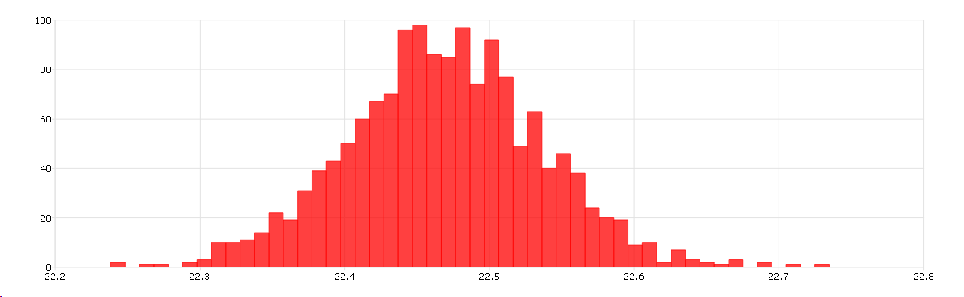

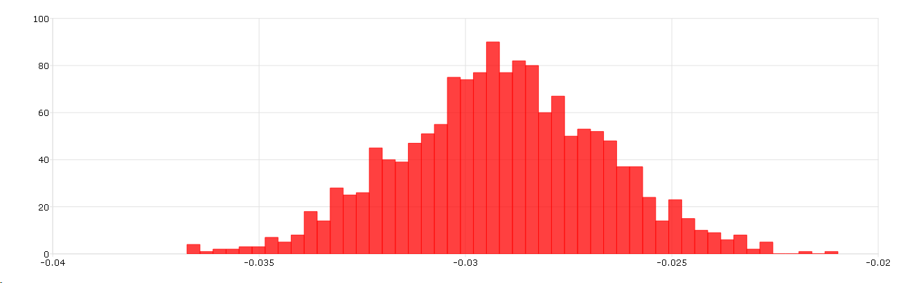

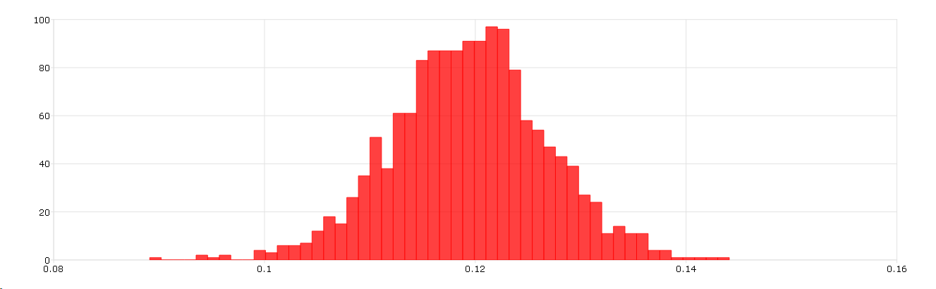

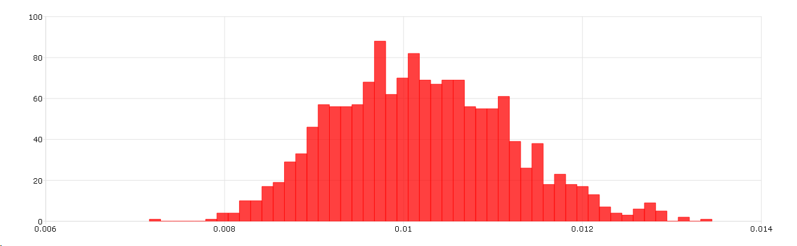

**Figura 14.** *Histogramas de $α_{0}$, $α_{1}$, $α_{2}$ y $σ^{2}$ del modelo (1) para la submuestra 1962q1-1979q3.*

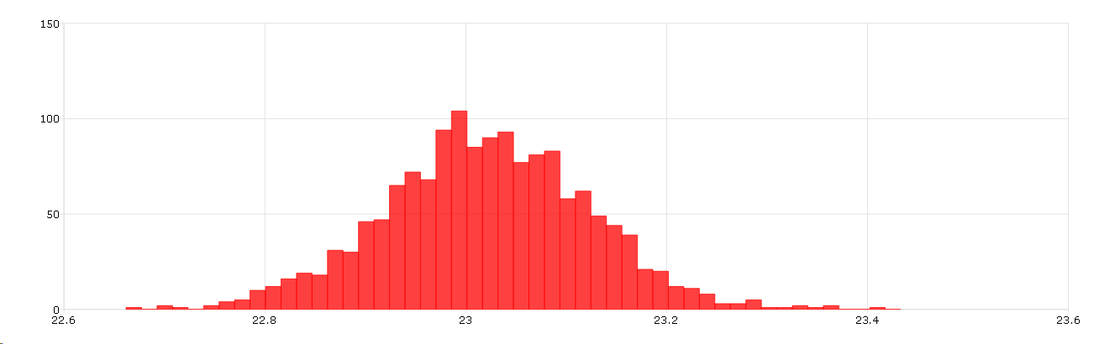

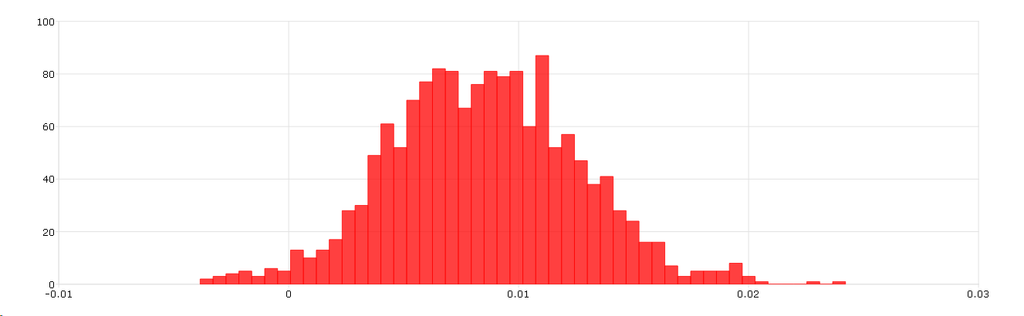

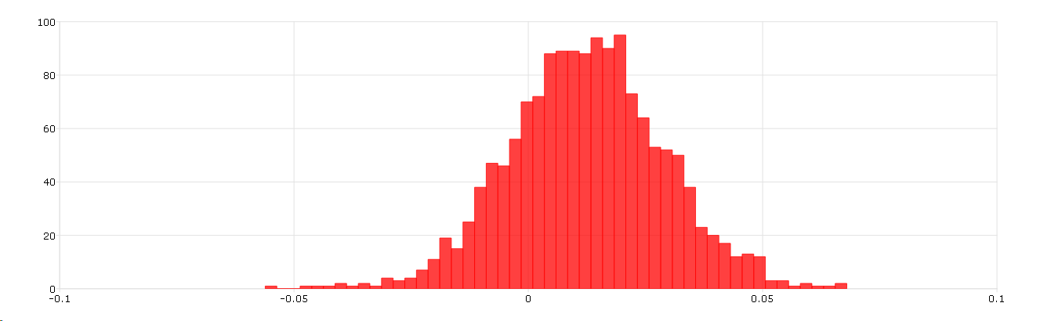

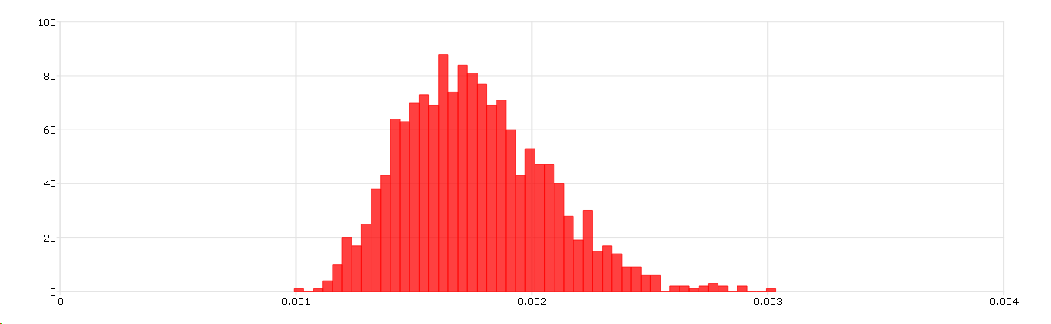

**Figura 15.** *Histogramas de $α_{0}$, $α_{1}$, $α_{2}$ y $σ^{2}$ del modelo (1) para la submuestra 1982q4-2014q4.*

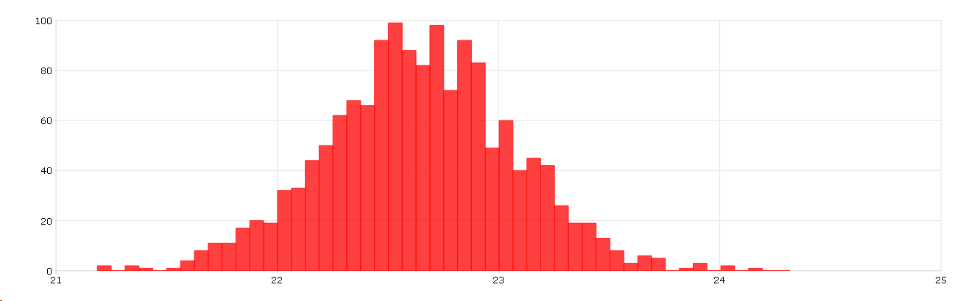

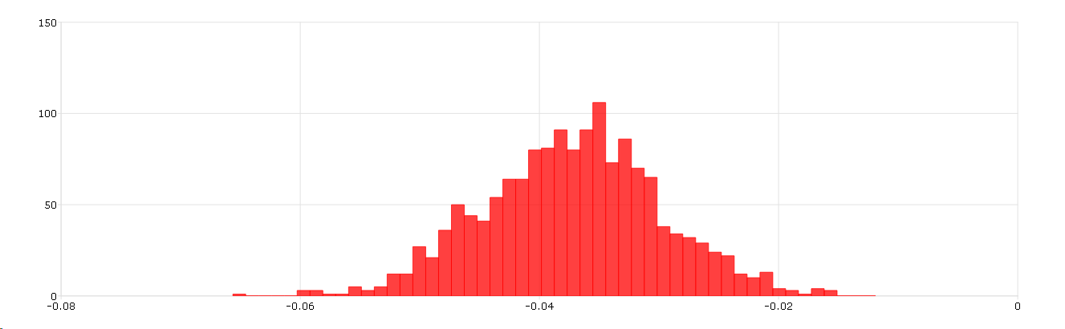

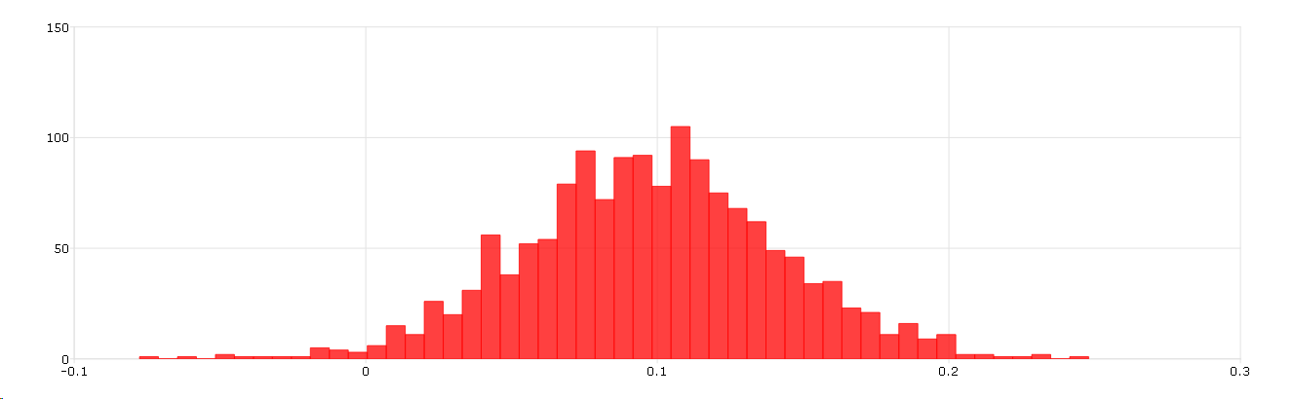

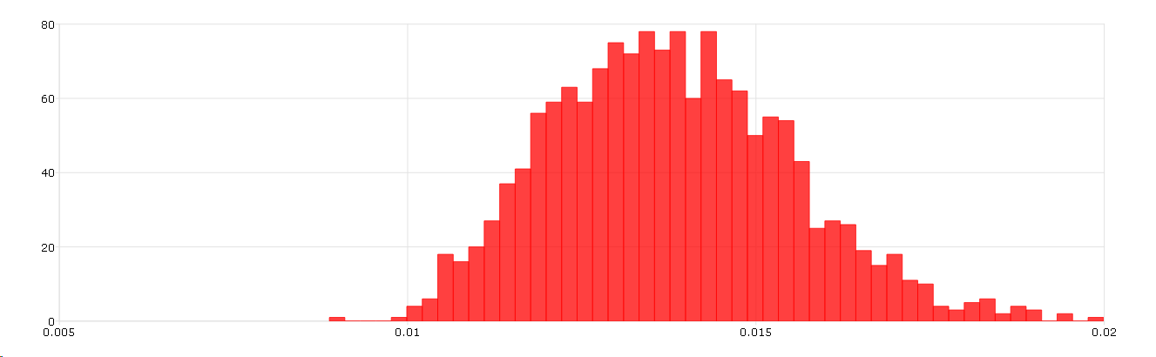

**(c)** *Repeat (a) and (b) for the following equations:*

$∆$*log ($m_{t}$) - $∆$ log ($p_{t}$)= $α_{0}$ + $α_{1}i_{t}$ + $α_{2}$ $∆$ log ($y_{t}$) + $ε_{t}$ (2)*

*and*

$∆$*log ($m_{t}$) - $∆$ log ($p_{t}$)= $α_{0}$ + $α_{1}∆i_{t}$ + $α_{2}$ $∆$ log ($y_{t}$) + $ε_{t}$. (3)*

*Critically comment on the similarities and differences of the results of (a)-(b) vs. the regressions in (c).*

En la tablas 20 y 21, se presentan los resultados de la estimación *Markov Chain Monte Carlo* del modelo (2) y del modelo (3), respectivamente, para toda la muestra y para la submuestras 1962q1-1979q3 y 1982q4-2014q4.

Se puede observar que, en ambos modelos, al igual que sucedía en el modelo (1), la dispersión de $α_{2}$ es menor en la submuestra 1962q1-1979q3 en comparación a la submuestra 1982q4-2014q4, siendo esta dispersión en la muestra completa un punto intermedio. Sin embargo, no sucede lo mismo con la dispersión de $α_{1}$, la cual, ahora, es menor en la muestra completa.

Por otra parte, comparando estos tres modelos, es menos probable que el modelo (1) sea estacionario, ya que las series económicas en niveles tienden a tener tendencia estocástica, en tanto que el modelo (2) y el modelo (3), al estar en primeras diferencias, es probable que sean estacionarios.

**Tabla 20.** *Resultados de estimación Markov Chain Monte Carlo del modelo (2).*

|  |  |  |  |  |  |
| --- | --- | --- | --- | --- | --- |
| **Muestra** | **Resultado** | $$α_{0}$$ | $$α_{1}$$ | $$α_{2}$$ | $$σ^{2}$$ |
| 1962q1-2014q4 | Media | 0,01653741 | -0,00196704 | -0,15218755 | 0,00020567 |
| Mediana | 0,01659135 | -0,00197043 | -0,14517289 | 0,00020436 |
| Desvío estándar | 0,00218934 | 0,00036824 | 0,11280627 | 0,00001869 |
| 1962q1-1979q3 | Media | 0,01448120 | -0,00335219 | 0,20310724 | 0,00003863 |
| Mediana | 0,01451254 | -0,00332815 | 0,20459038 | 0,00003771 |
| Desvío estándar | 0,00257266 | 0,00042847 | 0,07846957 | 0,00000661 |
| 1982q4-2014q4 | Media | 0,01984987 | -0,00171576 | -0,42654778 | 0,00028421 |
| Mediana | 0,01964314 | -0,00171700 | -0,41707292 | 0,00028087 |
| Desvío estándar | 0,00310561 | 0,00063820 | 0,23684816 | 0,00003386 |

Fuente: Elaboración propia.

**Tabla 21.** *Resultados de estimación Markov Chain Monte Carlo del modelo (3).*

|  |  |  |  |  |  |
| --- | --- | --- | --- | --- | --- |
| **Muestra** | **Resultado** | $$α_{0}$$ | $$α_{1}$$ | $$α_{2}$$ | $$σ^{2}$$ |
| 1962q1-2014q4 | Media | 0,01250557 | 0,00218661 | -0,50625041 | 0,00023291 |
| Mediana | 0,01255940 | 0,00207946 | -0,51183298 | 0,00023143 |
| Desvío estándar | 0,00218490 | 0,00104786 | 0,11780210 | 0,00002116 |
| 1962q1-1979q3 | Media | -0,00024210 | 0,00086986 | 0,04165959 | 0,00007414 |
| Mediana | -0,00021206 | 0,00075174 | 0,04519257 | 0,00007238 |
| Desvío estándar | 0,00246455 | 0,00157687 | 0,10566058 | 0,00001268 |
| 1982q4-2014q4 | Media | 0,01729059 | -0,00071621 | -0,76558310 | 0,00030127 |
| Mediana | 0,01706627 | -0,00093148 | -0,75401136 | 0,00029773 |
| Desvío estándar | 0,00336970 | 0,00323396 | 0,22494978 | 0,00003590 |

Fuente: Elaboración propia.

**Ejercicio 6 (file named merval.wtf1).**

**(a)** *Estimate a Markov Switching in Variance with 3 states for the returns of the MERVAL. NB: The series is stock prices; you should model the returns. HINT: You can adapt the routine gibs_s3: chapter 9 by Kim and Nelson (or code available on the web page). Compare your results with those obtained with the GARCH model in exercise 1.*

En la tabla 22, se presenta la estimación *Markov Switching in Variance* con tres regímenes para los retornos del MERVAL. Comparar las estimaciones del modelo *Markov Switching in Variance* (MSV) con el modelo GARCH permite ver cómo captura cada uno la dinámica de la volatilidad de los retornos del MERVAL. Se puede observar que:

* MSV: Por un lado, captura cambios de régimen en la volatilidad, lo que puede ser útil para detectar diferentes estados de volatilidad del mercado. Por otro lado, tiene un peor ajuste (mayor AIC y CS), pero es útil para detectar regímenes de volatilidad.
* GARCH: Por un lado, captura la persistencia y la influencia de los *shocks* pasados en la volatilidad actual, sin cambios abruptos de régimen. Por otro lado, tiene un mejor ajuste (menor AIC y SC) y proporciona una mejor explicación de la dinámica de los retornos, pero no captura cambios abruptos de régimen.

En resumen, el modelo MSV es más adecuado si se espera que la volatilidad del mercado cambie entre distintos regímenes de manera abrupta, mientras que el modelo GARCH es mejor para capturar la dinámica continua de la volatilidad influenciada por *shocks* pasados. La elección entre ambos dependerá del comportamiento específico de la serie temporal de los retornos del MERVAL y del objetivo del análisis.

**Tabla 22.** *Estimación Markov Switching in Variance con tres regímenes para los retornos del MERVAL.*

|  |  |  |  |  |
| --- | --- | --- | --- | --- |
| Dependent Variable: RETURNS_MERVAL | | | |  |
| Method: Markov Switching Regression (BFGS / Marquardt steps) | | | | |
| Date: 07/08/24 Time: 12:54 | | |  |  |
| Sample (adjusted): 3 399 | | |  |  |
| Included observations: 397 after adjustments | | | |  |
| Number of states: 3 | | |  |  |
| Fixed probability matrix: EJERCICIO_6A_REST | | | |  |
| Initial probabilities obtained from ergodic solution | | | | |
| Standard errors & covariance computed using observed Hessian | | | | |
| Random search: 25 starting values with 10 iterations using 1 standard | | | | |
| deviation (rng=kn, seed=12345) | | | |  |
| Convergence achieved after 14 iterations | | | |  |
|  |  |  |  |  |
|  |  |  |  |  |
| Variable | Coefficient | Std. Error | z-Statistic | Prob. |
|  |  |  |  |  |
|  |  |  |  |  |
| Regime 1 | | | | |
|  |  |  |  |  |
|  |  |  |  |  |
| C | -0.008994 | 0.007117 | -1.263778 | 0.2063 |
| LOG(SIGMA) | -2.976744 | 0.102626 | -29.00570 | 0.0000 |
|  |  |  |  |  |
|  |  |  |  |  |
| Regime 2 | | | | |
|  |  |  |  |  |
|  |  |  |  |  |
| C | -6.72E-05 | 0.002252 | -0.029827 | 0.9762 |
| LOG(SIGMA) | -3.629031 | 0.092371 | -39.28744 | 0.0000 |
|  |  |  |  |  |
|  |  |  |  |  |
| Regime 3 | | | | |
|  |  |  |  |  |
|  |  |  |  |  |
| C | 0.002015 | 0.001680 | 1.198898 | 0.2306 |
| LOG(SIGMA) | -4.580712 | 0.197734 | -23.16605 | 0.0000 |
|  |  |  |  |  |
|  |  |  |  |  |
| Common | | | | |
|  |  |  |  |  |
|  |  |  |  |  |
| RETURNS_MERVAL(-1) | -0.015937 | 0.043318 | -0.367911 | 0.7129 |
|  |  |  |  |  |
|  |  |  |  |  |
| Transition Matrix Parameters | | | | |
|  |  |  |  |  |
|  |  |  |  |  |
| P11-C | 3.703194 | 0.948624 | 3.903752 | 0.0001 |
| P22-C | -0.149046 | 0.882940 | -0.168807 | 0.8659 |
| P31-C | -3.767725 | 1.293914 | -2.911883 | 0.0036 |
| P32-C | 0.712841 | 0.777852 | 0.916423 | 0.3594 |
|  |  |  |  |  |
|  |  |  |  |  |
| Mean dependent var | -0.000545 | S.D. dependent var | | 0.027598 |
| S.E. of regression | 0.027770 | Sum squared resid | | 0.300766 |
| Durbin-Watson stat | 1.949509 | Log likelihood | | 927.0191 |
| Akaike info criterion | -4.614706 | Schwarz criterion | | -4.504320 |
| Hannan-Quinn criter. | -4.570979 |  |  |  |
|  |  |  |  |  |
|  |  |  |  |  |

**(b)** *Plot the histograms of the Volatility parameters. Comment the results.*

**(c)** *Estimate a two-state model using Eviews. Compare the results with those obtained in (a). Comment on the number of states.*

En la tabla 23, se presenta la estimación *Markov Switching in Variance* con dos regímenes para los retornos del MERVAL. Se puede observar que:

* Número de regímenes: El modelo de tres regímenes permite capturar más matices en la volatilidad de los retornos del MERVAL al tener un tercer estado que puede representar condiciones de mercado adicionales que el modelo de dos regímenes no puede. El modelo de dos regímenes simplifica la estructura de volatilidad, dividiendo el comportamiento del mercado en dos estados amplios.
* Significancia de los parámetros: Ambos modelos muestran que las medias de los retornos en los regímenes no son significativas, lo que sugiere que los retornos medios no difieren mucho entre los estados. Las log-varianzas son altamente significativas en todos los regímenes, indicando que las diferencias en la volatilidad son cruciales para distinguir entre los estados.
* Medidas de ajuste: El modelo de tres regímenes tiene un *log-likelihood* ligeramente mayor y mejores valores de AIC y HQC en comparación con el modelo de dos regímenes, lo que sugiere un mejor ajuste al permitir más complejidad en la estructura de volatilidad. La diferencia en Schwarz Criterion (SC) es mínima, indicando que el penalizar la complejidad adicional del modelo de tres regímenes no tiene un impacto significativo en la medida de ajuste.
* Parámetros de transición: En ambos modelos, los parámetros de transición son significativos, pero el modelo de tres regímenes permite más flexibilidad en las probabilidades de cambio entre estados.

En resumen, el modelo de tres regímenes ofrece una mejor capacidad para capturar la complejidad de la volatilidad de los retornos del MERVAL, aunque a costa de una mayor complejidad. El modelo de dos regímenes es más simple y aún puede capturar la esencia de la dinámica de volatilidad, pero puede perder detalles importantes que el modelo de tres regímenes puede captar. La elección entre estos modelos depende del equilibrio entre la simplicidad y la capacidad de capturar detalles más finos en la estructura de volatilidad.

**Tabla 23.** *Estimación Markov Switching in Variance con dos regímenes para los retornos del MERVAL.*

|  |  |  |  |  |
| --- | --- | --- | --- | --- |
| Dependent Variable: RETURNS_MERVAL | | | |  |
| Method: Markov Switching Regression (BFGS / Marquardt steps) | | | | |
| Date: 07/08/24 Time: 12:56 | | |  |  |
| Sample (adjusted): 3 399 | | |  |  |
| Included observations: 397 after adjustments | | | |  |
| Number of states: 2 | | |  |  |
| Initial probabilities obtained from ergodic solution | | | | |
| Standard errors & covariance computed using observed Hessian | | | | |
| Random search: 25 starting values with 10 iterations using 1 standard | | | | |
| deviation (rng=kn, seed=12345) | | | |  |
| Convergence achieved after 7 iterations | | | |  |
|  |  |  |  |  |
|  |  |  |  |  |
| Variable | Coefficient | Std. Error | z-Statistic | Prob. |
|  |  |  |  |  |
|  |  |  |  |  |
| Regime 1 | | | | |
|  |  |  |  |  |
|  |  |  |  |  |
| C | 0.000693 | 0.001148 | 0.603868 | 0.5459 |
| LOG(SIGMA) | -4.313830 | 0.070294 | -61.36866 | 0.0000 |
|  |  |  |  |  |
|  |  |  |  |  |
| Regime 2 | | | | |
|  |  |  |  |  |
|  |  |  |  |  |
| C | -0.001758 | 0.002702 | -0.650679 | 0.5153 |
| LOG(SIGMA) | -3.312446 | 0.062215 | -53.24184 | 0.0000 |
|  |  |  |  |  |
|  |  |  |  |  |
| Common | | | | |
|  |  |  |  |  |
|  |  |  |  |  |
| RETURNS_MERVAL(-1) | 0.003201 | 0.052063 | 0.061486 | 0.9510 |
|  |  |  |  |  |
|  |  |  |  |  |
| Transition Matrix Parameters | | | | |
|  |  |  |  |  |
|  |  |  |  |  |
| P11-C | 3.194058 | 0.562934 | 5.673952 | 0.0000 |
| P21-C | -3.129183 | 0.625710 | -5.001013 | 0.0000 |
|  |  |  |  |  |
|  |  |  |  |  |
| Mean dependent var | -0.000545 | S.D. dependent var | | 0.027598 |
| S.E. of regression | 0.027756 | Sum squared resid | | 0.301993 |
| Durbin-Watson stat | 1.975201 | Log likelihood | | 917.9626 |
| Akaike info criterion | -4.589232 | Schwarz criterion | | -4.518987 |
| Hannan-Quinn criter. | -4.561406 |  |  |  |
|  |  |  |  |  |
|  |  |  |  |  |